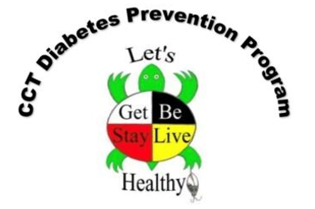
Diabetes Prevention Program Referral Form
This form will be completed by Diabetes Prevention staff in coordination with medical personnel to enroll you in services.
For more information, email charlene.bearcub.dib@colvilletribes.com or call (509) 634-2970 for help.

Referred to the Diabetes Prevention Program from (check one):
☐ Nespelem Indian Health Service, (509) 634-2913
☐ San Poil Valley Community Health Center, (509) 634-7300
☐ Omak Indian Health Service, (509) 422-7416
☐ Lake Roosevelt Community Health Centers, (509) 722-7006
☐ Other:

Patient name:
Mailing address:
Tribal enrollment number:
Phone:

Patient has a diagnosis of (check one):
☐ Diabetes Type I
☐ Diabetes Type II

Medical Personnel Signature:
Title:
Date:

Approved Signature:
Date:

